***Computer Practice assignment-2***

1. *To calculate the area and perimeter of a rectangle…*

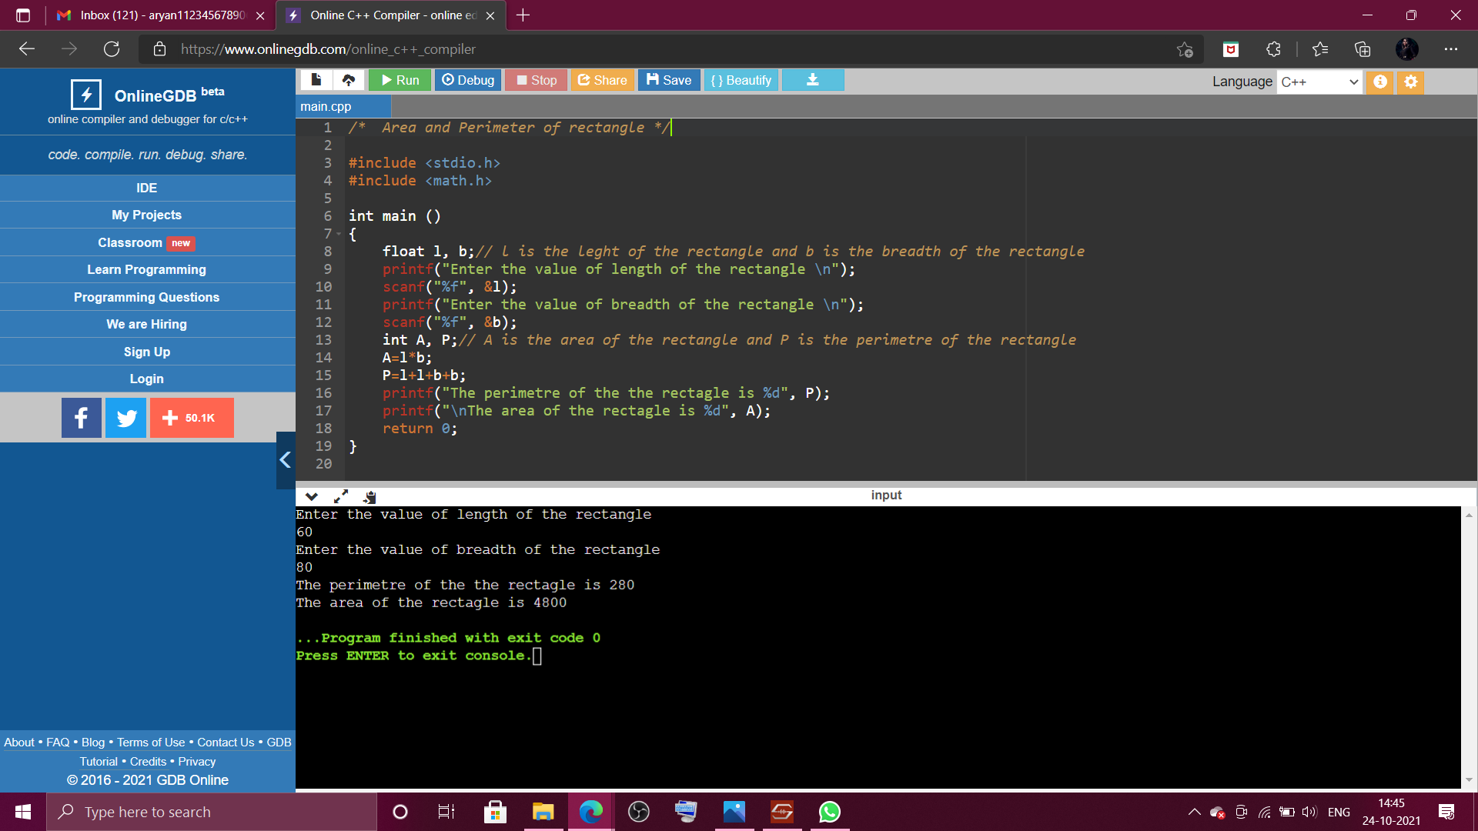

1. *Conversion of temperatures in various units of temperature…*

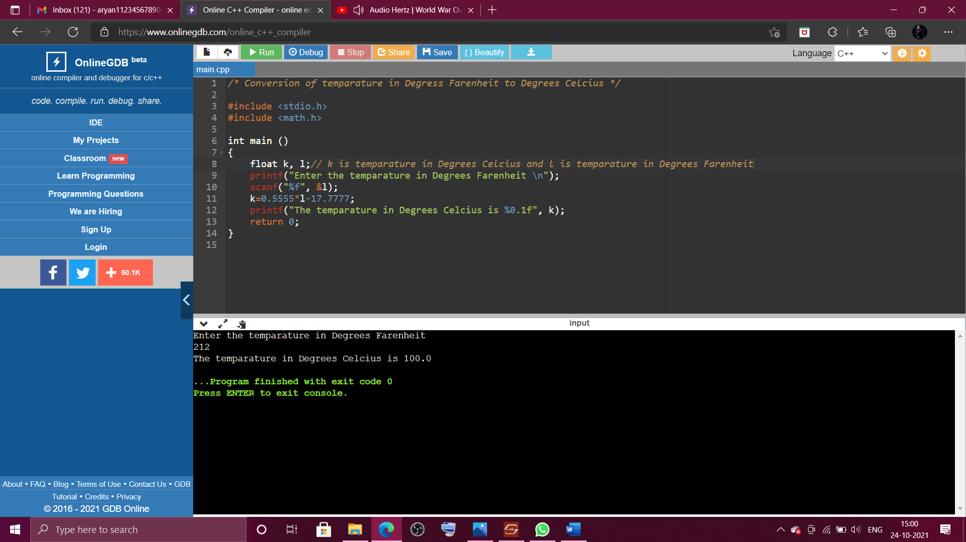

1. *To calculate area and circumference of a circle in real time…*

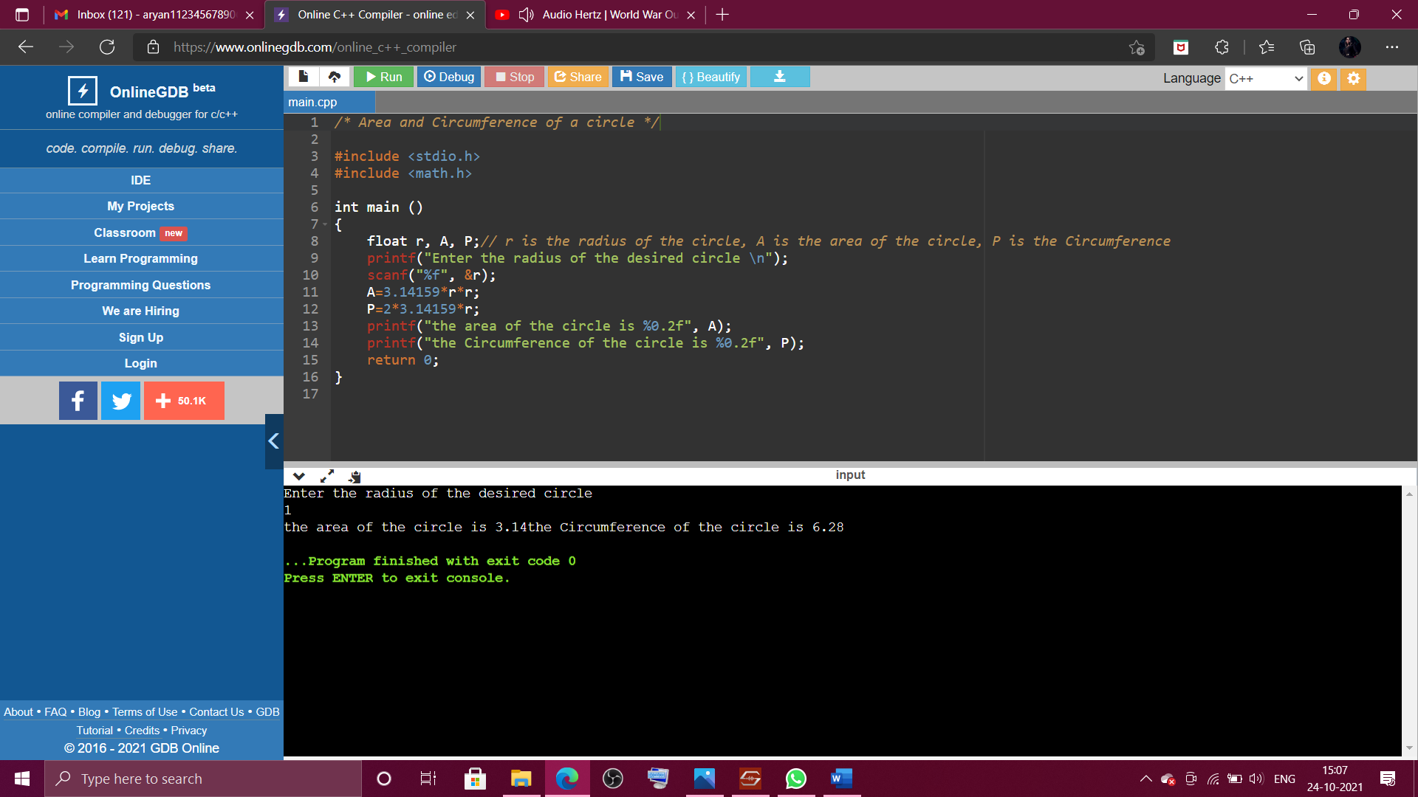

1. *Use of mathematical operators like sin, cos, log and power of a number…*

*Here 1.570795 is pi/2 that is 90 degrees.*

*Output of question no. 4 is in the next page due to space constraints…*

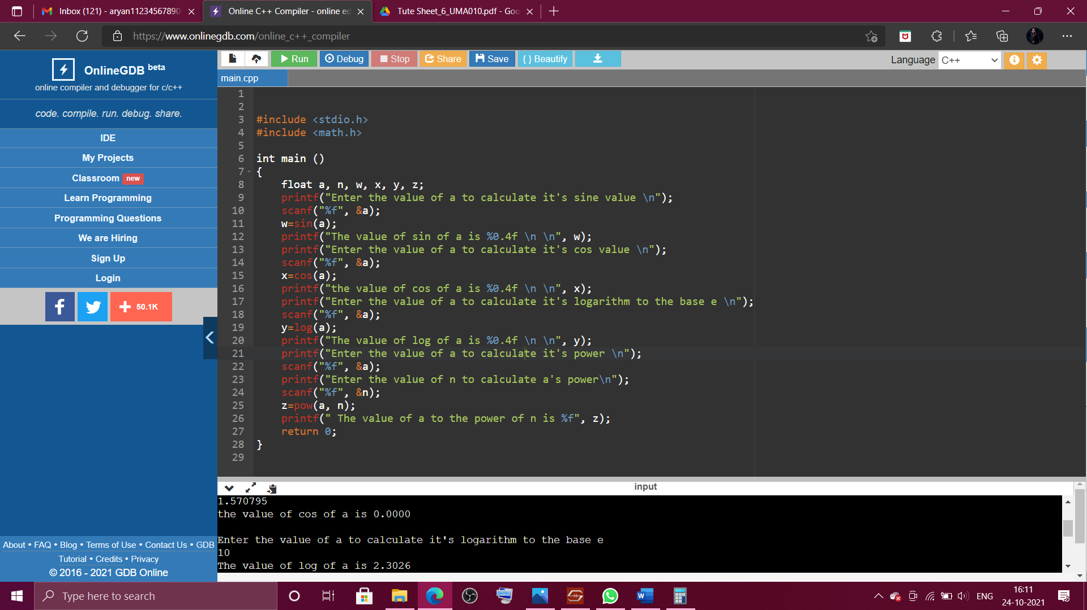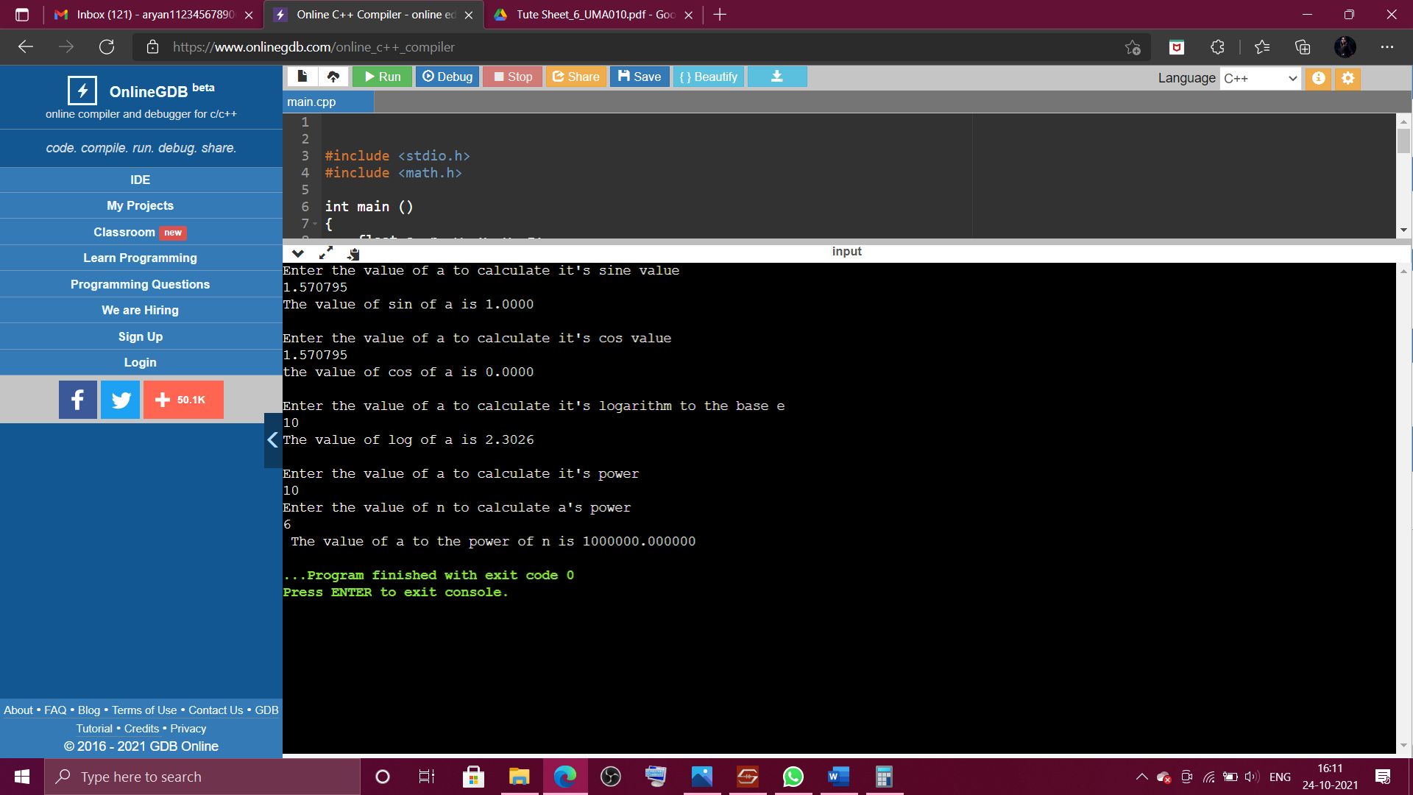

1. *Roots of Quadratic Equations… PTO for the output and code of this program…*

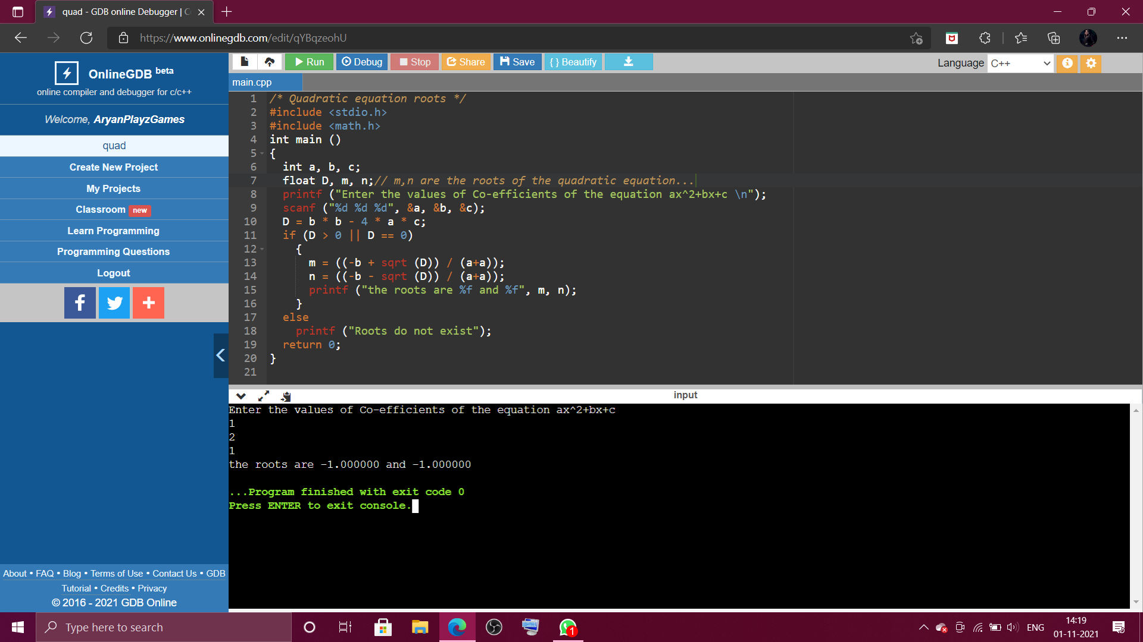

1. *Use of left shift and right shift operators…*

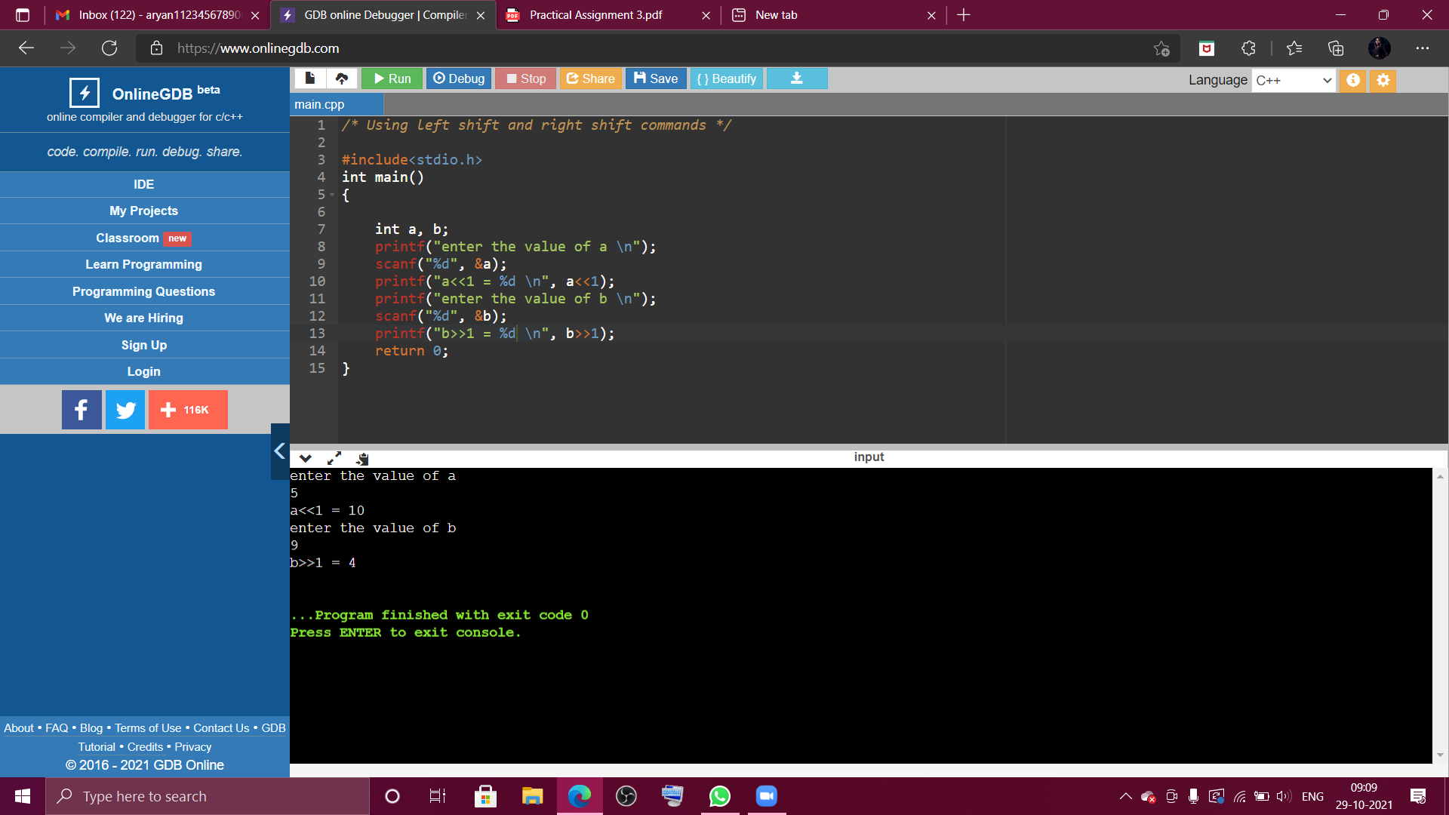

1. *Use of +=, -=, *=, %=, /= operators…*

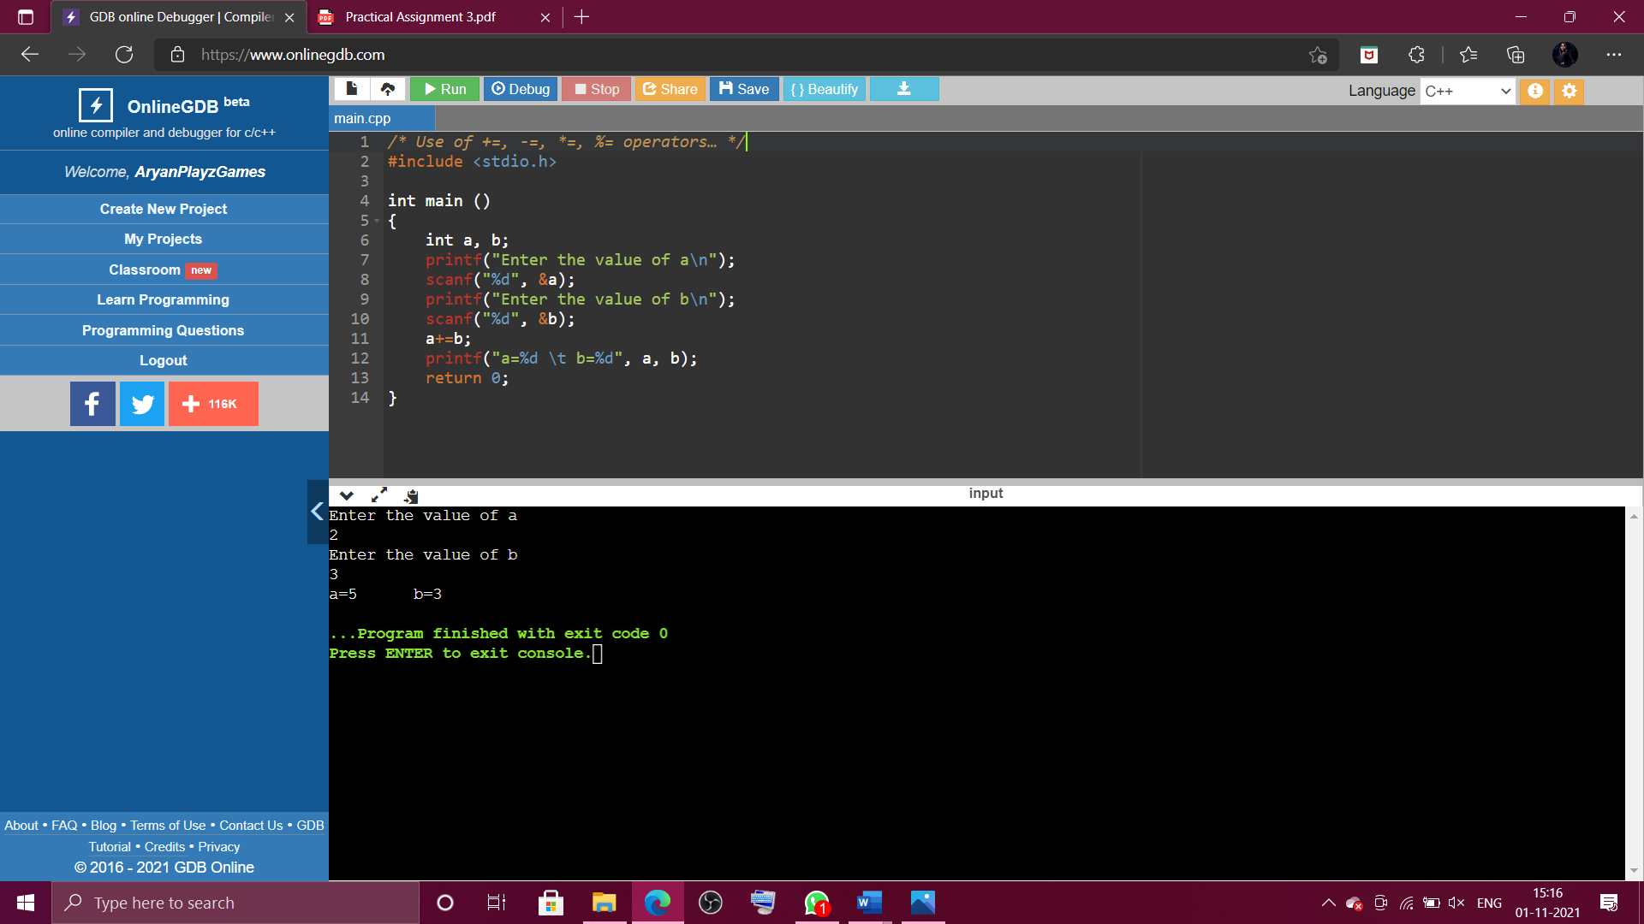 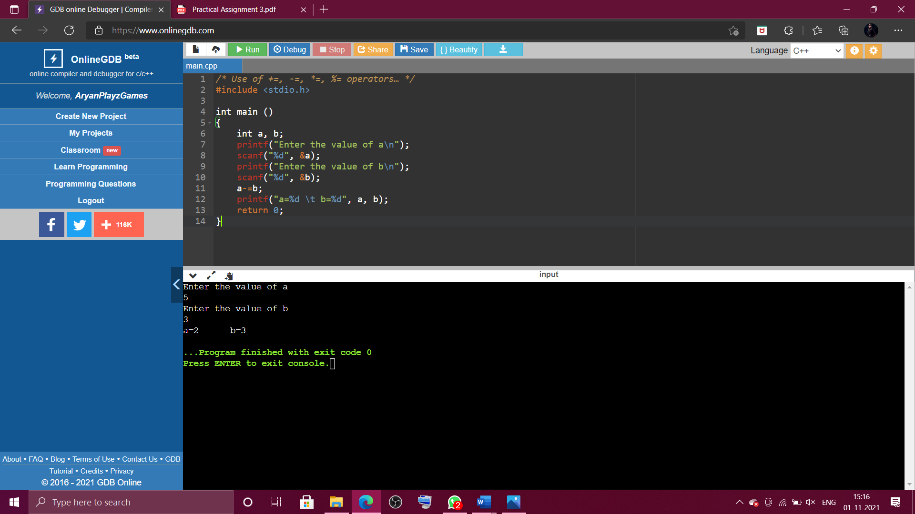 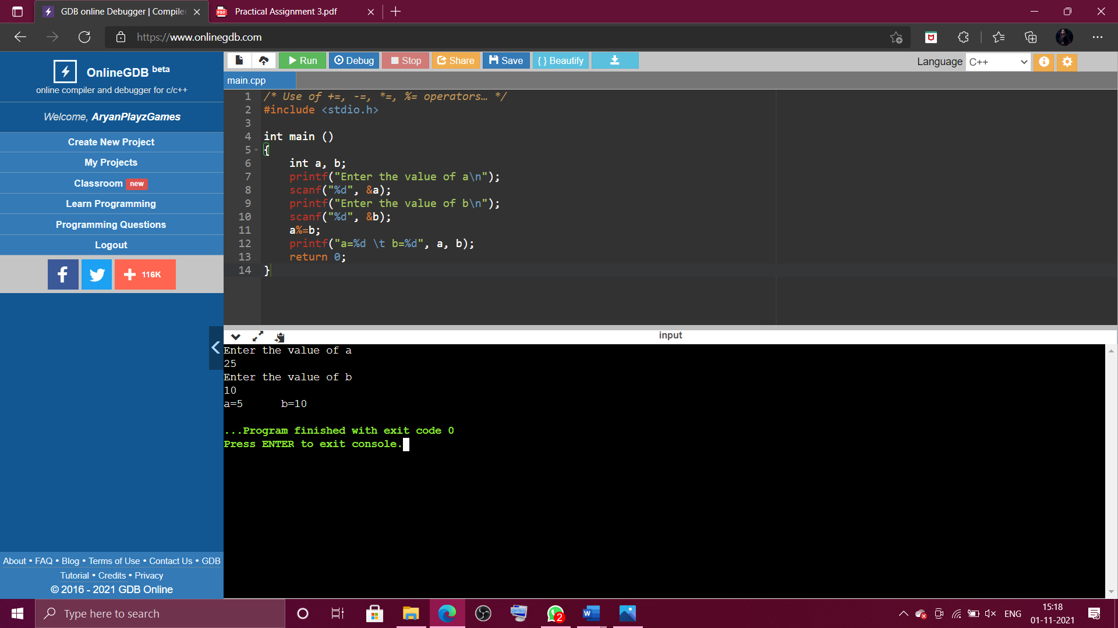 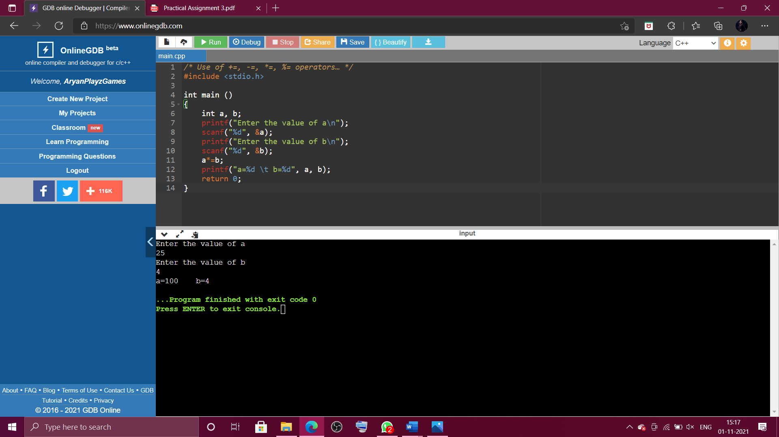

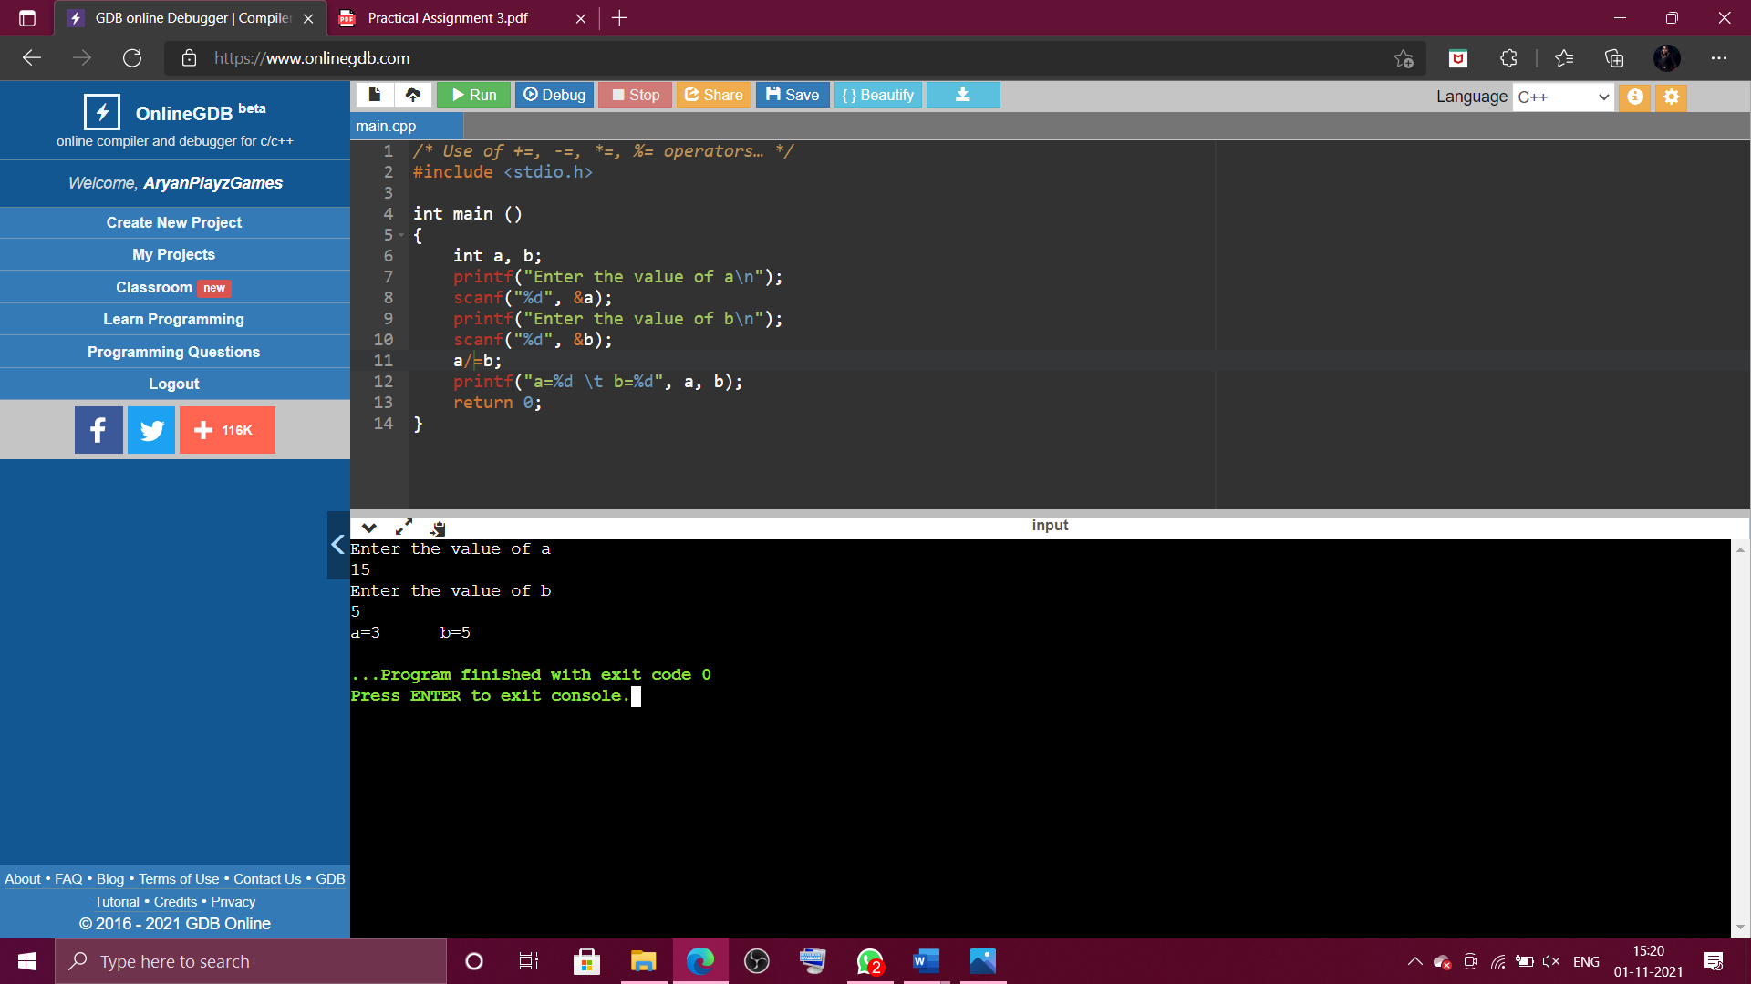

1. *To check whether a year is a leap year or not…*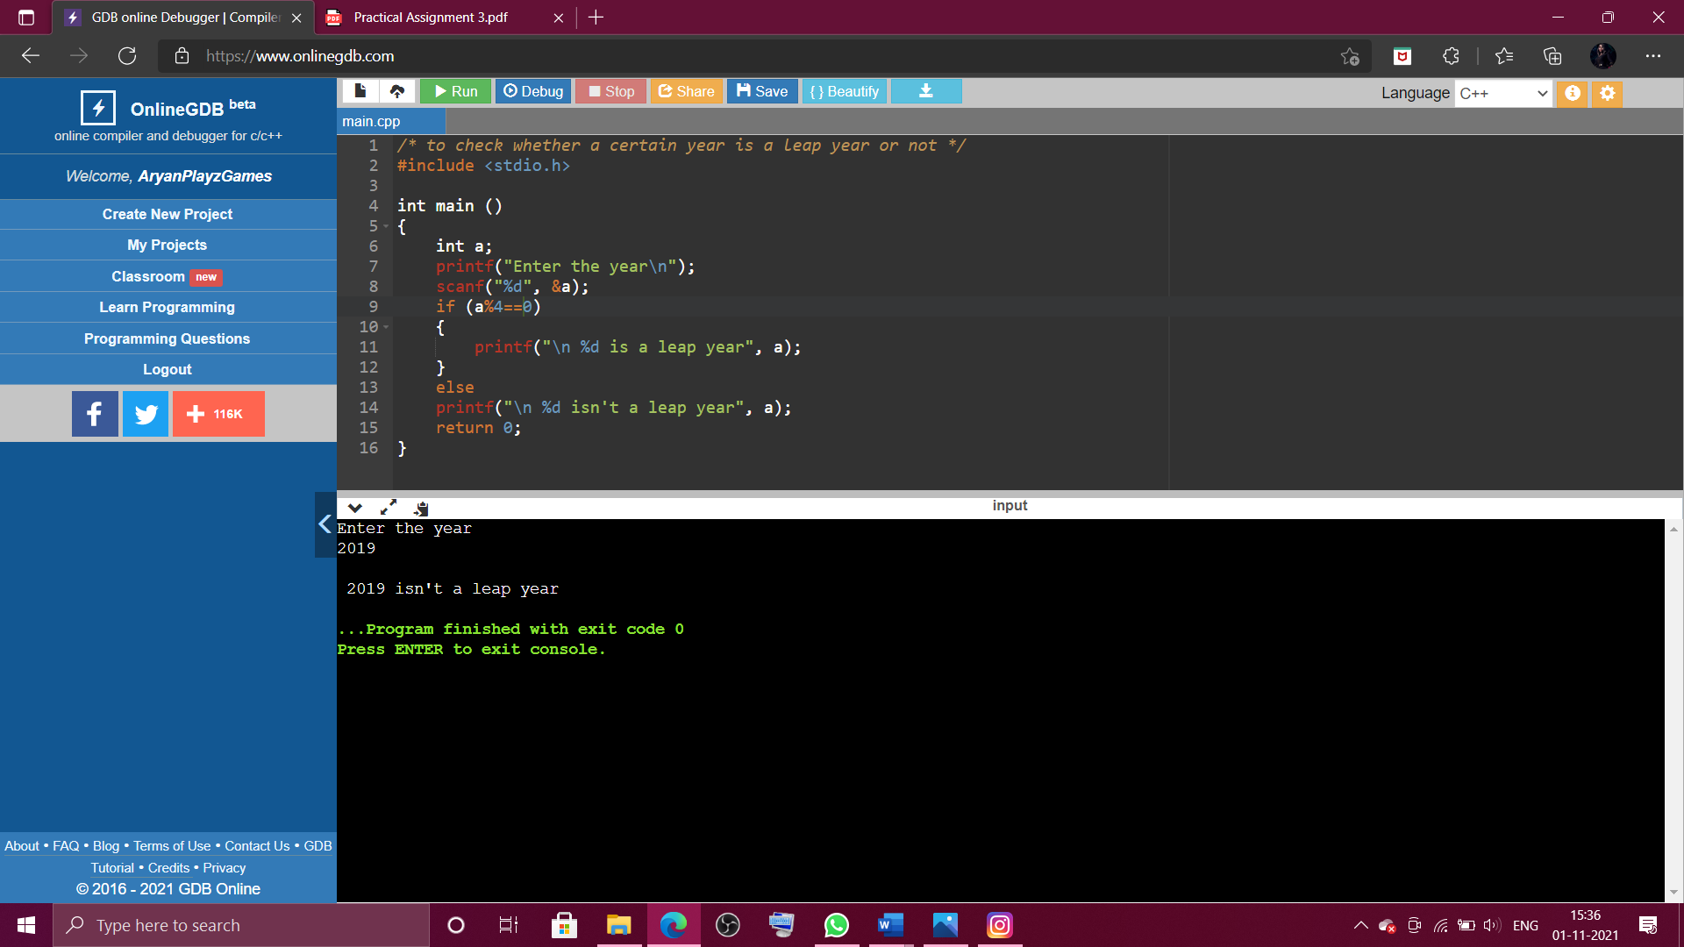

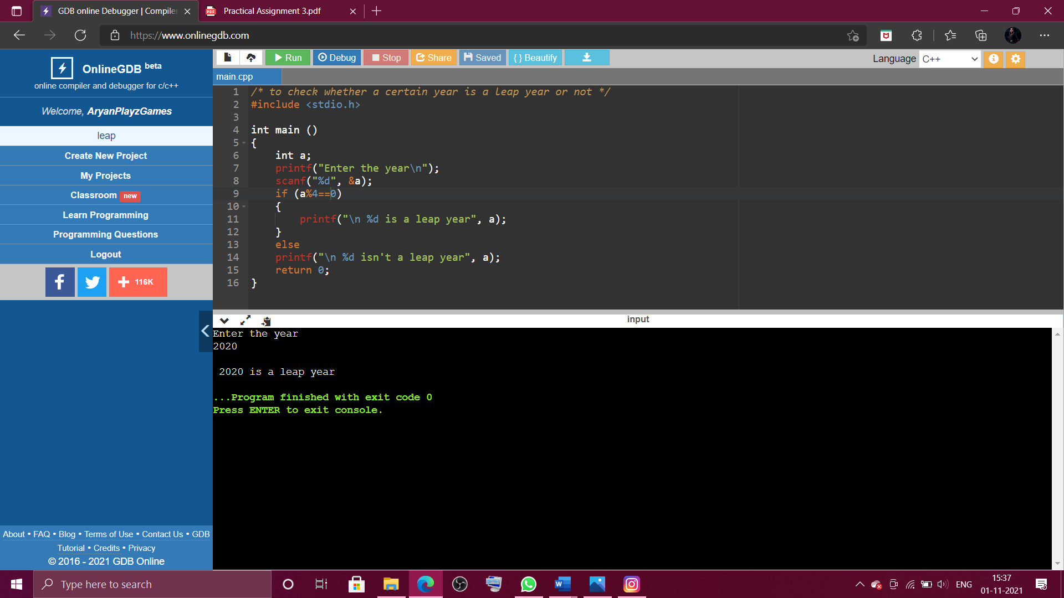

1. *Swapping values of two variables without using a third variable…*

